# 嵌套SQL查询的实验报告

姓名 学号 班级 日期

## 一、实验目的

掌握嵌套SQL查询用法.

## 二、实验内容

1. 运行脚本smallRelationsInsertFile.sql 或者 largeRelationsInsertFile.sql (见教学在线) 创建一个名为university数据库及其表格和数据.
2. 任选以上步骤中创建好的表格, 自己设计问题, 逐一展示如下命令的用法. 某些情况, 可能需要插入新的数据. 可参考教材例子.
   1. Set Operations: union, intersect, except
   2. Set Comparison: some, all
   3. Test for Empty Relations: exists
   4. Test Duplicate Tuples: unique
   5. from 后接子查询
   6. with ... as ...

## 三、实验环境

1. 操作系统: ????根据实际情况填写此处
2. 数据库: ????根据实际情况填写此处

## 四、实验步骤

1. 建立数据库并插入数据

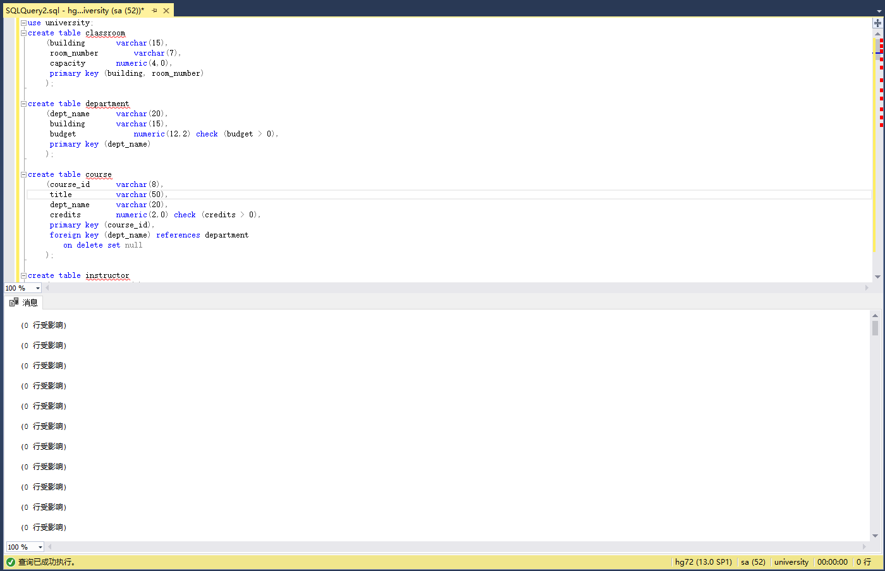

2. 命令执行

（1）Set Operations：

Union：

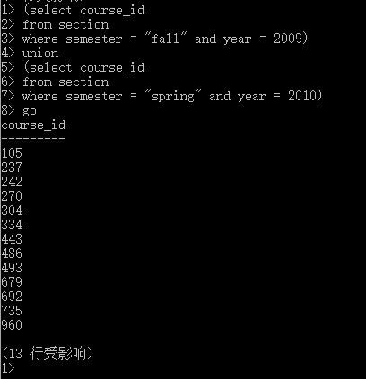

Intersect：

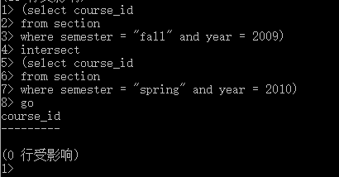

Except：

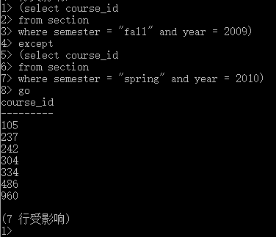

1. Set Comparison

Some:

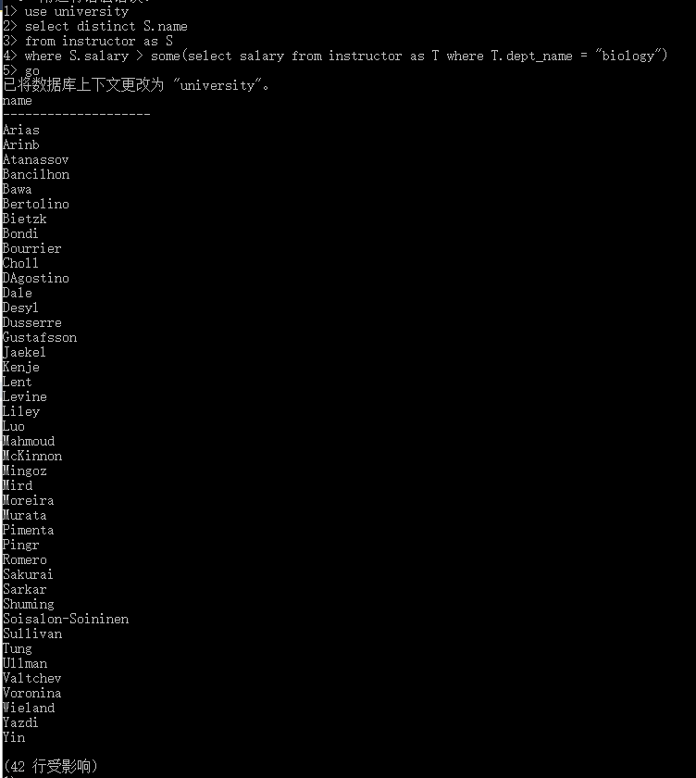

All:

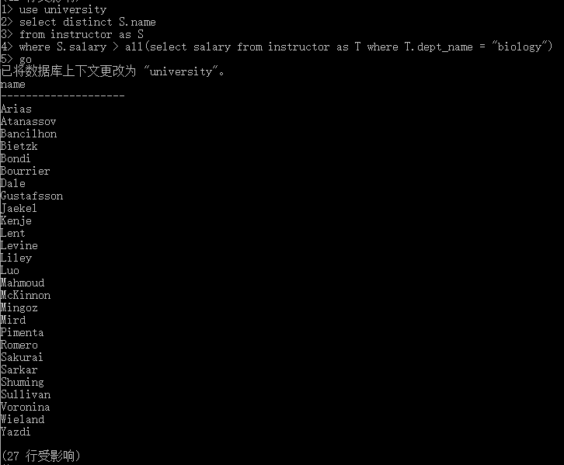

1. Exists

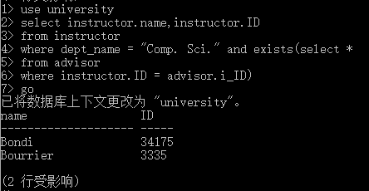

1. Unique

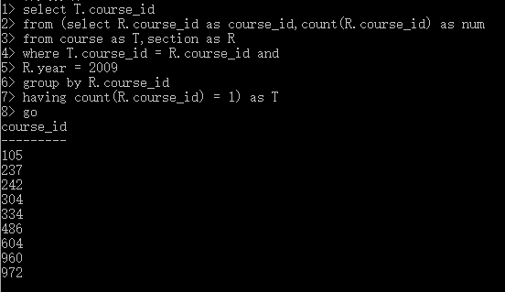

（5）from 后接子查询

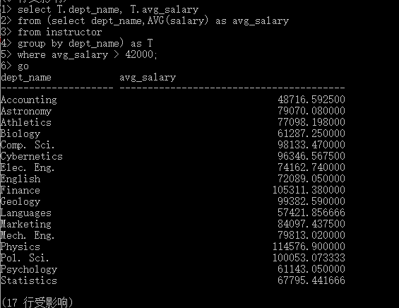

1. With……As

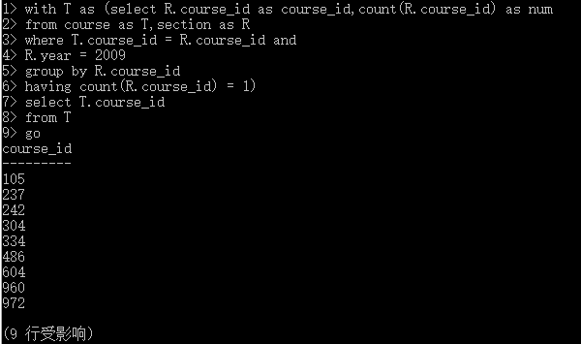

代码：

// Union

(select course_id

from section

where semester = "fall" and year = 2009)

union

(select course_id

from section

where semester = "spring" and year = 2010)

// Intersect

(select course_id

from section

where semester = "fall" and year = 2009)

intersect

(select course_id

from section

where semester = "spring" and year = 2010)

// Except

(select course_id

from section

where semester = "fall" and year = 2009)

except

(select course_id

from section

where semester = "spring" and year = 2010)

// Some

use university

select distinct S.name

from instructor as S

where S.salary > some(select salary from instructor as T where T.dept_name = "biology")

// All

use university

select distinct S.name

from instructor as S

where S.salary > all(select salary from instructor as T where T.dept_name = "biology")

// Exists

use university

select instructor.name,instructor.ID

from instructor

where dept_name = "Comp. Sci." and exists(select *

from advisor

where instructor.ID = advisor.i_ID)

// Unique

use university

select i_id,count(i_id) as students

from advisor

group by i_id

having count(i_id) = 1

// Not unique

use university

select i_id,count(i_id) as students

from advisor

group by i_id

having count(i_id) > 1 or count (i_id) < 1

//

select T.course_id

from (select R.course_id as course_id,count(R.course_id) as num

from course as T,section as R

where T.course_id = R.course_id and

R.year = 2009

group by R.course_id

having count(R.course_id) = 1) as T

//

select T.dept_name, T.avg_salary

from (select dept_name,AVG(salary) as avg_salary

from instructor

group by dept_name) as T

where avg_salary > 42000;

//With as

with T as (select R.course_id as course_id,count(R.course_id) as num

from course as T,section as R

where T.course_id = R.course_id and

R.year = 2009

group by R.course_id

having count(R.course_id) = 1)

select T.course_id

from T

## 五、实验总结

可以写心得体会, 也可以写发现的问题, 没有硬性要求.